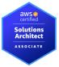

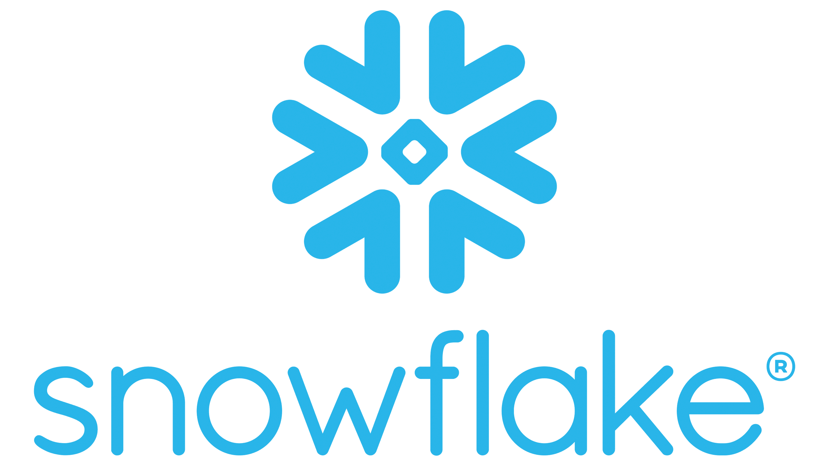Name: Anjaneyulu Pagadala
Tech: Snowflake / Lead Data Engineering
Email: kareem@aplombtek.com
Ph: (973) 475-5411
Visa: H1B || Location: Houston, Texas
LinkedIn ID: www.linkedin.com/in/anjaneyulu-pagadala-a5a09115b

PROFESSIONAL SUMMARY
- Sr Data Engineer with around 13+years of experience, familiar with Data Warehousing, Data extraction, data quality checks, cleaning, transforming and data modeling, performance optimization and data security, database design, troubleshooting for executing data-driven solutions with background in Data Science as well. Experienced in architecture, design, and development of lightweight ETL pipelines with large datasets.
- 6+ years of experience in Snowflake beginning with POCs for AIG to Migrating data marts & business processes from Oracle to snowflake
- 12+ years of experience in SQL, Pl/SQL & Datawarehouse tools
- Expert in using Snowflake, Oracle, AWS Cloud, IBM Infosphere DataStage, SQL/PL-SQL, Python, Shell Scripting and Statistics to support business decision-making.
- Experience in the design and development of enterprise applications and products in Retail, Actuarial, Retirement insurance and Finance domains.
- Experience in developing ETL processes within Relational Databases, Data Lake, Data Mart architecture, and both on premises and AWS cloud technologies.
- Strong working experience with SQL databases, data modeling and data pipelines. Involved in end-to-end development and automation of ETL pipelines using SQL and Python.
- Proficient in leveraging AWS ( S3, Lambda, SNS) cloud platforms to design and implement scalable data engineering solutions.
- Monitored and managed Glue job performance with CloudWatch, implementing alerting and logging for better tracking of data processing health and job statuses.
- Adept at designing cutting-edge, cloud-based data warehousing solutions using Snowflake on AWS, optimizing schemas, tables, and views for streamlined data storage and retrieval.
- Expertise in optimizing query performance and scalability in Snowflake through Micro partitioning strategies and multi-cluster warehouses.
- Extensively used Direct Data sharing, Cloning, Time Travel, Scale Up, scale out, Secure views and Internal, Named Stages in Snowflake to provide cost effective and better performance solutions
- Extensive experience in using Transient tables, Views, Micro partitioning, Clustering, Snow pipes to auto ingest files from AWS buckets
- Worked on building centralized Data Lake on AWS Cloud utilizing primary services like S3, EMR, Redshift,and Athena.
- Using python scripting to generate customized data quality controls
- I have experience in Optimizing storage and computer cost by using Cloning, Transient Databases ,
- Sound experience in implementing end to end automated batch processing using Autosys, Control M scheduling tools with Job dependencies, trigger files & time bounded triggers
- Expertise in debugging performance issues and identifying solutions to improve performance using PL/SQL tuning techniques, Snowflake virtual warehouse scales out and scale up techniques and IBM Data stage parallel processing capabilities.
- Experience in integration of various data sources like Oracle, DB2 SQL Server, Snowflake into different stages of Data warehouse project implementation.
- Implemented SQL Procedures, Packages, Functions at Database level using SQL and PL/SQL scripting along with tables, partitioning, Indexes and Views
- Have extensive experience in different versions of IBM DataStage and experience in developing DataStage Parallel jobs and Server jobs using various parallel processing mechanisms.
- Worked on IBM DataStage client tools like DS Designer, DS Director, DS Manager and DS Administrator.
- Experience in Designing, Compiling, Testing, Debugging, Scheduling, and running IBM DataStage jobs.
- Well-versed in the analysis, design, and development of enterprise applications and Legacy application migration.
- Experienced in requirement analysis, application development, application migration and maintenance using Software Development Lifecycle (SDLC) and Python technologies.
- Experience with software engineering standard methodologies like Unit testing, Integration testing with Control committee, Peer Code reviews and Continuous delivery.
- Strong experience in using CI/CD and DevOps tools like Git, Jenkins, and other tools like WinSCP, Putty, JIRA, Service Now and Confluence.
- Conducted thorough debugging/troubleshooting and implemented performance tuning strategies for ETL pipelines
- Experienced in creating high-level/low-level design documents for data models, proactively identifying customer needs throughout the complete lifecycle.
- Excellent experience in dealing with onshore and offshore business stakeholders, PMO teams and client interactions.
- Have knowledge in reporting tools like Sigma, Tableau, Power BI, MicroStrategy, Business Objects

TECHNICAL SKILLS
Category | Tools/Technologies
Programming Languages | SQL,Python, Shell Scripting/Unix/Bash Scripting
Database Technologies | Oracle, Snowflake, MS SQL, Teradata, DB2
ETL Tools | IBM DataStage
Development Tools | Microsoft SQL Studio, Toad
BI Tools | Tableau, Power BI, Sigma and MicroStrategy
SDLC Methodologies | Agile, Waterfall, Test Driven Development
AWS Cloud | EC2, S3, CloudWatch,SNS, SQS, Lambda, IAM
Schedulers | Autosys, Control M, Airflow
CI / CD Platforms | Git, Jenkins, Visual Studio Code
IDEs and Tools | Visual Studio Code, JIRA, Confluence, Service Now
Operating Systems | Windows OS, Ubuntu (Linux), Mac OS

PROFESSIONAL EXPERIENCE

TCS - Corbridge Financial | Los Angeles Sep 2022 – Present
Role: Lead Data Engineer
Responsibilities:
- Involved in conducting analysis of business requirements for Reinsurance Settlement, GAAP, Statutory and Cashflow Testing processes.
- Leading a team of 5 offshore resources and 2 onshore resources
- Building design, Dataflow diagrams and presenting them to Architects, Business users and several other stake holders.
- Expert in using Snowflake, Oracle, AWS Cloud, IBM Infosphere DataStage, SQL/PL-SQL, Python, Shell Scripting and Statistics to support business decision-making.
- Migration of data from Oracle Actuarial Data repository and transactional data bases to Snowflake
- Extensively used snowflake Named stages, Streams, Stored procedures, UDFs to load data into Landing tables, Staging Tables and Mart tables from sources like transactions databases, Flat files.
- Using time travel concepts of snowflake to recover the accidental deletion of the data or to analyze the point of time data issues for reporting and reconciliation purposes
- Creating Direct shares from another snowflake accounts using secure views and tables to avoid duplicating data in different snowflake accounts and restricting the access only to allowed audience.
- Using snowflake masking policies features to secure the PII data
- Built data quality controls frameworks using python script which provides data reconciliation between raw data tables in snowflake and source tables (Check sum & count)
- Designing and implementing SOX data quality controls and presenting them to the governance and control committee.
- Automating and productional zing the end-to-end process using Autosys JIL script
- Created several control reports using Sigma reporting tool to reconcile the data between source and target systems
- performance tuning of Snowflake queries, IBM DataStage jobs and Oracle Stored procedures
- Guiding the development team on understanding the data lineage and help them to implement it
- Understand the existing ETL code in DataStage and rewrite it for snowflake database
- Used the DataStage Designer to develop jobs to extract, transform and load data from various source systems into the Data Warehouse
- Integrated Lambda with CloudWatch to set up monitoring and alerting for data processing jobs, ensuring proactive error handling and resource optimization
- Taking care of adhoc data needs of Actuaries, Data scientists and Reinsurance business users
- Ingested data from various sources, including RDBMS (Oracle/SQL Server), Mainframe VSAM, File-based (csv, Json, lz4), logs into Snowflake via IBM DataStage, Talend, COPY INTO and Snow pipe.
- Conducted data analysis using Python/Spark and its libraries and collaborated with downstream teams to shape data according to their requirements.
- Extensively used snowflake time travel queries to reconcile the dollar amounts at a certain point of time in two different data modeling systems.
- Created data shares between two different snowflake accounts to provide solutions for reinsurance treaties.
- Created misclustered virtual warehouses with different sizes (S, M , L) for different purposes (BI, Experience studies, ETL loading and Stored procedures)
- Built real-time data streaming solutions using AWS Lambda in combination with Kinesis to process and analyze data on the fly, improving decision-making time for key business operations.
- Designed and created end to end data quality controls using Sigma tool.
- Involved in the analysis of user stories and developing POCs to ensure solution suitability.
- Utilized various techniques including data partitioning, indexing for query optimization to enhance parallel data processing efficiency.
- Performed testing and data validation tasks to support data migration.
- Managed the deployment of workflows into production, version control, and data checks using CI/CD tools like Bitbucket and Jenkins.
- Utilized Autosys for scheduling jobs and orchestration.
- Integrated AWS Glue Crawlers with ETL workflows, enabling automatic schema detection and data classification, and eliminating the need for manual data schema creation in Amazon Redshift and S3.
- Created generic Unix/Shell and Python scripts to automate the manually performed activities.
- Created High-level (HLD) and Low-level (LLD) design documents for data models.
- Peer code review created Sox Control for Data Quality and assisted business stakeholders for Data analysis.
- Experienced GIT for version control and used Jenkins for CI/CD pipelines.
Environment: AWS Cloud, Snowflake, IBM Infosphere DataStage 11.7, Oracle ExaCC, PL/SQL, Shell Scripting, Python, AWS Lambda, , CloudWatch, SNS, SQS, JIRA, ServiceNow, Autosys, Airflow, and Windows Server 2016, UNIX, and Microsoft Visio. Tableau, Power BI and Sigma

TCS - AIG| Los Angeles April 2018 – Aug 2022
Role: Data Engineer

Responsibilities:
- Analyzed data pipelines to debug, troubleshoot, and identify root causes of issues, making code corrections to improve data quality and reliability.
- Analyzed the requirements for Experience study (Data science) project in Individual retirement insurance – Fixed Index Annuity, Fixed Annuity and Variable Annuity.
- Created Dataflow design documents for Experience study project and presented to Level 4 and Level 3 Management.
- Intensely involved with admin system SMEs to create mapping documents and data dictionary
- Worked on POCs to understand the cost and budget implications to migrate Oracle to snowflake along with IT architect in Actuarial team
- Created misclustered virtual warehouses with different sizes (S, M , L) for different purposes (BI, Experience studies, ETL loading and Stored procedures)
- Created data shares between two different snowflake accounts to provide solutions for reinsurance treaties.
- Used snowflake cloning features to use the production copy in non-production environments for Data quality and regression analysis
- Integrated Snowflake with AWS for managing raw and semi-structured data from/to AWS S3.
- Automated reports using Shell scripts and Python to streamline the process.
- Analyzed data pipelines to debug, troubleshoot, and identify root causes of issues, making code corrections to improve data quality and reliability.
- Extensively used snowflake time travel queries to reconcile the dollar amounts at a certain point of time in two different data modeling systems.
- Designed and created end to end data quality controls using Sigma tool.
- performance tuning of SQL DML queries, IBM DataStage jobs and Oracle Stored procedures
- Guiding the development team on understanding the data lineage and help them to implement it
- Understand the existing ETL code in DataStage and rewrite it for snowflake database
- Used the DataStage Designer to develop jobs to extract, transform and load data from various source systems into the Data Warehouse
- Enhanced overall server performance by 15% by fine-tuning SQL queries and optimizing embedded PL/SQL blocks within Oracle 19c.
- Reduced database reconstruction time by 20% by implementing table partitioning and Oracle's parallel execute feature.
- Created a process to load data to over 1,500 tables from source systems to Oracle using IBM DataStage tool
- Developed and codified database structure that processed 1 terabyte of complex business data daily.
- Taking care of adhoc data needs of Actuaries, Data scientists and Reinsurance business users
- Handled client presentations as part of the delivery activities.
- Monitored application performance and conducted defect/incident management for production deployments.
- Handled production failure in hyper care with incidents from ServiceNow, ensuring timely resolution and minimal impact on operations.
- Achievements:
- Handled client presentations as part of the delivery activities.
- Monitored application performance and conducted defect/incident management for production deployments.
Environment: AWS Cloud, Snowflake, IBM Infosphere DataStage 11.7, Oracle ExaCC, PL/SQL, Shell Scripting, Python,AWS S3,AWS Lambda, CloudWatch, SNS, SQS, MSSQL, JIRA, ServiceNow, Autosys, and Windows Server 2016, UNIX, and Microsoft Visio.

Tata Consultancy Services - AIG EMEA| Hyderabad, India, October 2016 – March 2018
Role: Sr ETL Developer
Responsibilities:
- Reviewed the BRD and created Technical Design document and Provided Efforts Estimation based on the complexity of the deliverables.
- Interaction with Data base architects, database IT team, SME teams and business users regarding procedures which support the efficient design of structures at ETL level.
- Proposed a solution to isolate the data country wise and reviewed the table changes script which is created by DBA team
- Customized the Entity relationship data model to enhance DW to support Global Countries data.
- Designed complex SQL query to extract data from Netezza tables.
- Altered already existing Jobs and stored procedure to support Europe countries data Integrated new HR bank feed with Workday feed using new data stage jobs
- Developed jobs in Designer using different stages like XML, ODBC connector, Netezza Connector, Transformer, Aggregator, Funnel, Remove Duplicate, Lookup and Merge.
- Used the DataStage Designer to develop jobs for extraction, transforming and loading data into data warehouse database.
- Involved in developing Fusion Data Marts for the user reporting requirements.
- Used DataStage Director and the runtime engine to schedule running the jobs, monitoring, and debugging its components.
- Worked on Data loading and transformations using DataStage from Oracle Connector using PL/SQL.
- Analyzed the different legacy source systems data and created ETL process to load the into SAP systems.
- Performed manual and solution manager reconciliation between source and SAP data and analyzed the reasons for the variance and created remediation to fix the variances.
- Requirement gathering from the client and development of the functional library, questionnaire, and dashboards as per the client needs.
- Documented the closure memo and result document with test results, code block, data profiling, dashboards, manual reconciliation, solution manager reconciliation and remediation log in each cycle (Unit testing, Mock, Dress rehearsals and Live)
- Handover the baseline solution manager report to Finance and controlling team
- Involved in analysis, requirements gathering, function/technical specifications, development, deploying and testing.
- Preparing the detail design document for the feature and getting approvals from the architects.
- Created Shared Containers for reusable calculations in various strings.
- Attending the CAB meetings to get the approvals for migrating the code to the Production.
- Created DataMart (DM) for running the model runs for the business.
- Extensively used Data Stage Designer stages such as ODBC, Aggregator, Transformer, Join, Pivot, SAP BAPI, ABAP Extractor and Merge.
- Extensively used Email Notification, Nested Condition, Sequencer and Terminator activities in Job Sequences.
- Adding the file watcher jobs for generating email notification for Business Users if there is any dependency.
- Developed Routines for Error handling and developed before/after job subroutine.
- Knowledge on Store procedures, Functions, and packages in PL/SQL for Data ETL.
- Written SQL scripts to create and drop the indexes those are passes as parameters in the pre & post sessions.
- Involved in investigating & solving data integrity issues.
- Worked on scheduling tool control M for monitoring and scheduling jobs.
- Wrote UNIX shell Scripts for file validation and scheduling DataStage jobs.
- Some of the target DB’s are MS SQL, Netezza, Oracle
Environment: IBM Infosphere DataStage 8.5, Oracle 12c/11g, PL/SQL, Autosys, Netezza, Microsoft SQL server, Qlik View, JIRA, Shell Scripts, UNIX (Sun Solaris 8) and Windows 2012/2008.
Tata Consultancy Services - Target | Chennai & Montevideo, Uruguay – December 2011 – Oct 2016
Role: Application support

Responsibilities:
- Extensively used Data Stage 8.5 Designer stages such as ODBC, SAP BAPI, ABAP Extractor, Oracle connector, Sequential File Stage, Merge, Aggregator, Transformer, Join, Pivot to fix the production failures
- Supported Enterprise Data Warehouse applications
- Running and monitoring batch jobs (Monthly, Weekly and Daily) in Control M
- On-call support – fixing high severity batch and online problems in the production system.
- Fixing system issues through Problem Management
- Identify Incident Reduction opportunities
- Service Change Requests - to implement certain enhancements per client’s need
- Supporting Business client issues on SAP Business warehouse reporting issues.
- Fixing DataStage ETL errors and data errors.
- Completing payment jobs on time and sending checks to printer through control m and DataStage batch jobs.
- Improved the performance of the DataStage jobs using good partitioning techniques and splitting the bigger jobs into smaller ones.
Environment: IBM WebSphere Information Server 8.5, BMC Control M, SAP Process Integration, SAP Business Warehouse, SAP ECC (FI, MM and SRM), SQL Server, Oracle 11g, Unix Shell Script, MFT - Sterling Integrator by IBM
EducationAL QUALIFICATION
Bachelor of Technologies in Electronic and communications Engineering, Acharya Nagarjuna University, AP, India

Credentials: Snowflake

